|  |  |  |  |  |  |  |  |  |  |  |  |  |  |  |  |
| --- | --- | --- | --- | --- | --- | --- | --- | --- | --- | --- | --- | --- | --- | --- | --- |
|  |  |  | AZ KI  Software engineering | | |  | |  | |  | |  | |  |  |
|  |  |  |  | | |  | |  | |  | |  | |  |
|  |  |  |  | | |  | |  | |  | |  | |  |  |
|  |  |  | Why from whom? | | |  | |  | |  | |  | |  |  |
|  |  |  |  | | |  | |  | |  | |  | |  | Education |
|  |  |  | One of the main reasons for the emergence of this service by the Ezki site is that insurance agents and marketers cannot use the services of all insurance companies, and this issue has tied the hands of insurance marketers and agents to maintain and expand their customers. In fact, the insurance industry has representatives and marketers who, traditionally, can only provide the services of an insurance company to their customers, and in this situation, insurance representatives are forced to introduce some of their customers to other insurance companies and offices.  After Ezki.com's investigations, it was found that to eliminate the above gap, it is very helpful to set up an online collaboration service for sales. It means that conditions should be provided for insurance agents and marketers to be able to buy all types of insurance from all insurance companies for their customers online and also to be sure that the relationship with their customers is established only by themselves and they can refer them to regular buyers and Become your loyal. In this way, the "Ezkissler" service was launched. |  |  | |  | |  | |  | | 2023  **computer engineer** | | |
|  |  |  |  |  | |  | |  | | course | | |
|  |  |  |  |  | |  | |  | |  | | |
|  |  |  |  |  | |  | |  | | Software engineering | | |
|  |  |  |  |  | |  | |  | | Link | | |
|  |  |  |  |  | |  | |  | |  | | |
|  |  |  |  |  | |  | |  | | [Shayan138190@gmail.com](mailto:Shayan138190@gmail.com)  (+98)-9101943345  **Amirshayan JALILI** | | |

1. What is AZKI?
2. General and one-way cases
3. **User registration and login**

**USE CASE**

**Use case diagram**

Implementation by HTML

**Sequence diagram**

1. **Insurance search (third party)**

**USE CASE**

**Use case diagram**

Implementation by HTML

**Sequence diagram**

1. **Buying insurance** and **online** payment

**USE CASE**

**Use case diagram**

**Sequence diagram**

1. **Support**
2. **USE CASE**
3. **Use case diagram**
4. **Sequence diagram**

# AZ KI ; The new playground for insurance agents and marketers

**What are the advantages of Ezki for insurance agents and marketers?**

Let's review some of the features of Azki:

**1. The possibility of buying from all insurance companies:**

The most important advantage of Ezki is that it doesn't matter which insurance company you represent, any representative can buy insurance for his client from all insurance companies. In fact, in Ezki, there is no limit for selling the insurance required by the customer, which will eventually increase the number of customers of insurance agents and marketers .

**2. No need to stop cooperation with the insurance company:**

In order to use Ezki's service, insurance agents and marketers do not have to cut off their connection with the company they represent. Insurance agents and marketers can, in addition to selling all types of insurance from the main company they represent, sell other insurances at the same time .

**3. Azaki's commitment not to communicate with clients of representatives:**

One of the most important advantages of Ezki is that insurance agents and marketers can safely register customer information in the panel, because Ezki fully commits to sellers that it will not communicate with customers (without the sellers' request or approval) .

**4. Fast deposit of fees and staggered calculation:**

The fee for selling insurances in Ezki is deposited weekly and it is not necessary for insurance sellers to wait until the end of the month. Also, if the insurances sold to customers through Ezaki are renewed in the following years, the fee will be paid to the account of the same agent or marketer. The method of calculating the fee is also determined in a staggered manner and according to the amount of sales of the representatives. To put it simply, the higher the sales of the insurance agent and marketer, the higher the commission percentage will be .

**5. No limitation in time and place:**

In Ezki panel, in addition to selling all types of insurance from all insurance companies, there is no time or place limit for sellers. They can register their sales anytime and anywhere .

**6. Free membership and registration:**

Ezki, by defining a sales panel, allows insurance agents to operate online and meet the needs of their customers by registering and becoming a free member on the Ezki platform .

**How to use AZ KI?**

The way to use the Ezki panel is that they only have to register the customer's information in the panel and spend their time on the next customer. Ezki performs the entire process of issuing the insurance policy and sending it to the customer. Ezaki also offers special services to sellers that can help them attract new customers.

Insurance marketers and agents can use facilities such as auto body insurance inspection (by themselves) and online claim payment service for customers by becoming a member of Ezki, which will be very attractive to their customers. Also, Ezki's support team does not leave sellers alone at any time of the day or night. Ezaki is ready to support and respond 24 hours a day .

In addition to all these advantages, Ezaki provides free educational content to sellers so that they can increase their sales day by day.

Covered insurances

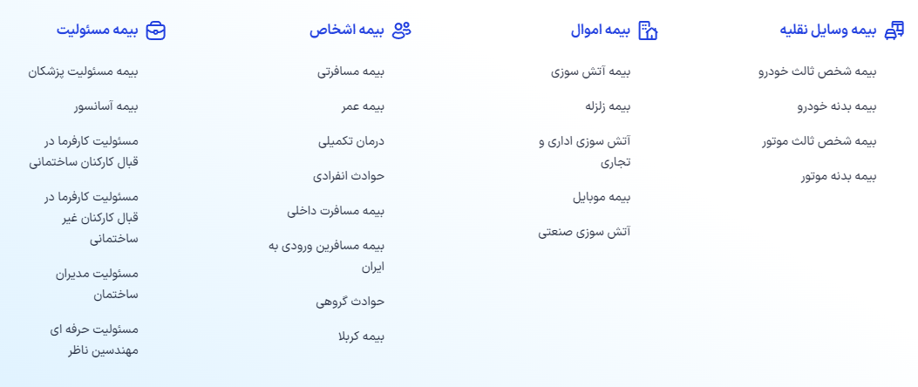

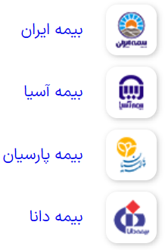

**Covered companies**

For an Ezki site, you can consider the following general and one-way usecases :

1. **User registration and login** : The user must be able to log in to the site or create a user account .
2. **insurance search** : The user must be able to search for the type of insurance he wants .
3. **Buying insurance** And **online** payment : the user must be able to buy the insurance he wants .
4. **Obtaining an insurance policy** : The user must be able to obtain his insurance policy .
5. **Support** : The user should be able to contact the support team if they have any questions or problems .

**User registration and login**

***USE CASE***

**User registration** :

1. The user clicks on the " login and registration" option .
2. The user enters his phone number
3. The system sends a one-time use code
4. The user enters the one-time password that was sent
5. The system checks the code
6. The user enters the required information. This information can include username, password
7. The user clicks on the "Continue" button .
8. The user will be directed to the login page to log in to their account .

**User login** :

1. The user clicks on the " login and registration" option
2. The system asks to enter the password
3. If you forget or enter it incorrectly, the system will suggest a one-time use code
4. The user enters the received mod and applies it to the item panel

***Use case diagram***

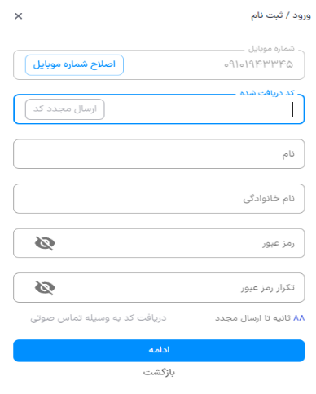

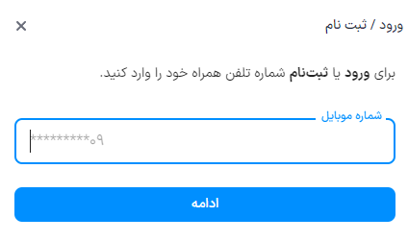

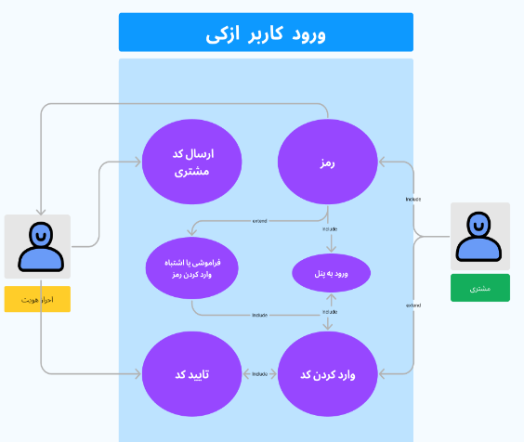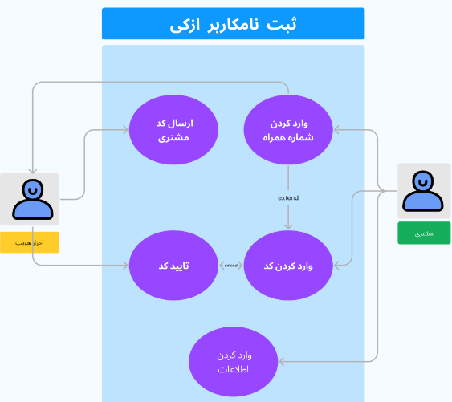

Implementation by HTML

< !DOCTYPE html >

< html dir = "rtl" >

<head> _ _

    < title > Login / Registration </ title >

    <style> _ _

body {

font - family : Arial, sans - serif;

margin : 0 ;

            padding : 0 ;

background - color: #f0f0f0;

}

form {

width : 300px ;

            margin : 30 px auto;

            padding : 20px ;

            border : 1 px solid #ccc;

background - color: #fff;

            border - radius: 5 px;

}

        input [ type = "text" ], input [ type = "password" ] {

width : 100 % ;

padding: 10px ;

margin: 10 px 0 ;

border: 1 px solid #ccc;

}

        input [ type = "submit" ] {

width : 100 % ;

padding: 10px ;

border: none;

color: #fff;

background - color: #007BFF;

cursor: pointer;

margin - top: 10px ;

}

        input [ type = "button" ] {

width : 100 % ;

padding: 10px ;

border: none;

color: #000;

background - color: #fff;

cursor: pointer;

margin - top: 10px ;

}

        input [ type = "submit" ]:hover, input [ type = "button" ]:hover {

background - color : #0056b3;

}

h2 {

text - align : right;

}

label {

display : block;

            margin : 10px 0 ; _

}

    </style> _ _

</head> _ _

<body> _ _

    < h2 > login / Registration </ h2 >

    <form> _ _

        < label for = "phone" > Phone number : </ label >

        < input type = "text" id = "phone" name = "phone" >

        < label for = "code" > Received code : </ label >

        < input type = "text" id = "code" name = "code" >

        < label for = "first_name" > Name : </ label >

        < input type = "text" id = "first_name" name = "first_name" >

        < label for = "last_name" > Last name : </ label >

        < input type = "text" id = "last_name" name = "last_name" >

        < label for = "password" > Password : </ label >

        < input type = "password" id = "password" name = "password" >

        < label for = "confirm_password" > Repeat password : </ label >

        < input type = "password" id = "confirm_password" name = "confirm_password" >

        < input type = "submit" value = " continue " >

        < input type = "button" value = " Back " onclick = "history.back()" >

    </form> _ _

</body> _ _

</ html >

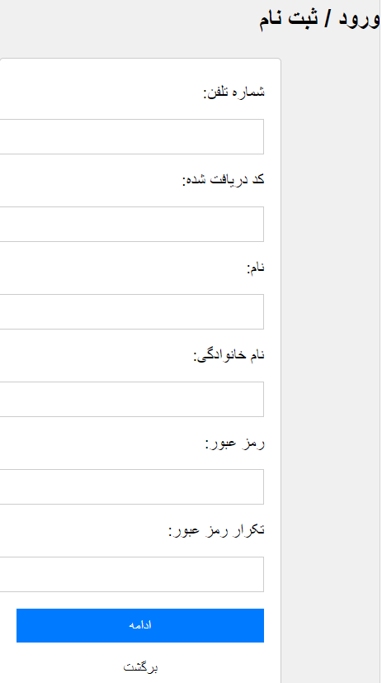

***Sequence diagram* m**

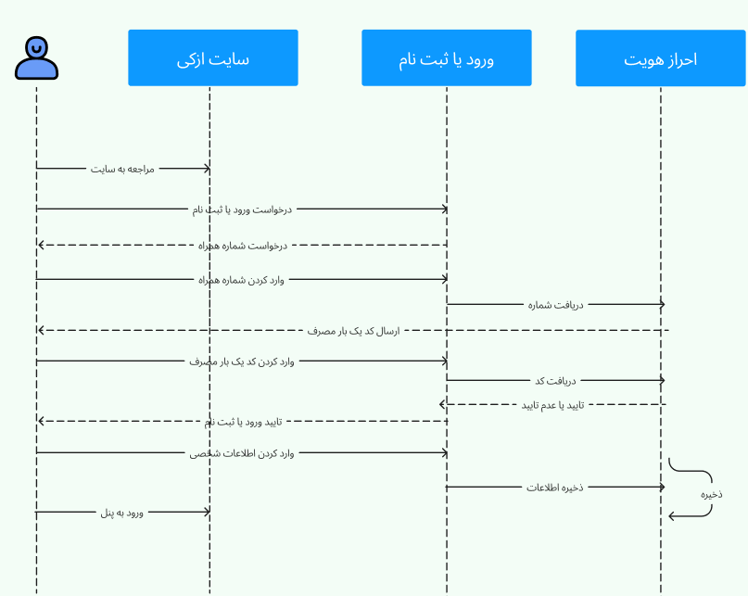

|  |  |  |  |  |  |
| --- | --- | --- | --- | --- | --- |
| **Name used: login or registration** | | | | | |
| The purpose of this use case is for the user to enter the Ezki site | | | | | **Description** |
| Authentication | | | | | **Factor I see** |
|  | Action Factor | System response | |  | **current Main** |
|  | The user registers or logs in | . 2) The system asks for the customer's phone number | |
|  | (3) Enter the number | (4) Sends the verification code | |
|  | 4) Enter the verification code | (5) The system checks the code | |
|  | (6) enter personal information | (7) issues permission to enter the panel | |
|  | Do not duplicate the desired number | | -1 |  | **before Condition** |
| The desired password must be entered with the correct formant | | -2 |  |
|  | |  |  |
| user enters the panel, he can modify his profile | | | | | **So Condition** |

**Insurance search (third party)**

***Use case***

1. The user enters the site
2. He clicks on the insurance option
3. He chooses his type of insurance from the list (third party)
4. Enters the license plate
5. Enters the national code of the car owner
6. The system performs authentication
7. If the car has insurance, the system will announce the type of insurance, otherwise it will go to the insurance comparison page for the customer to choose.

***Use case diagram***

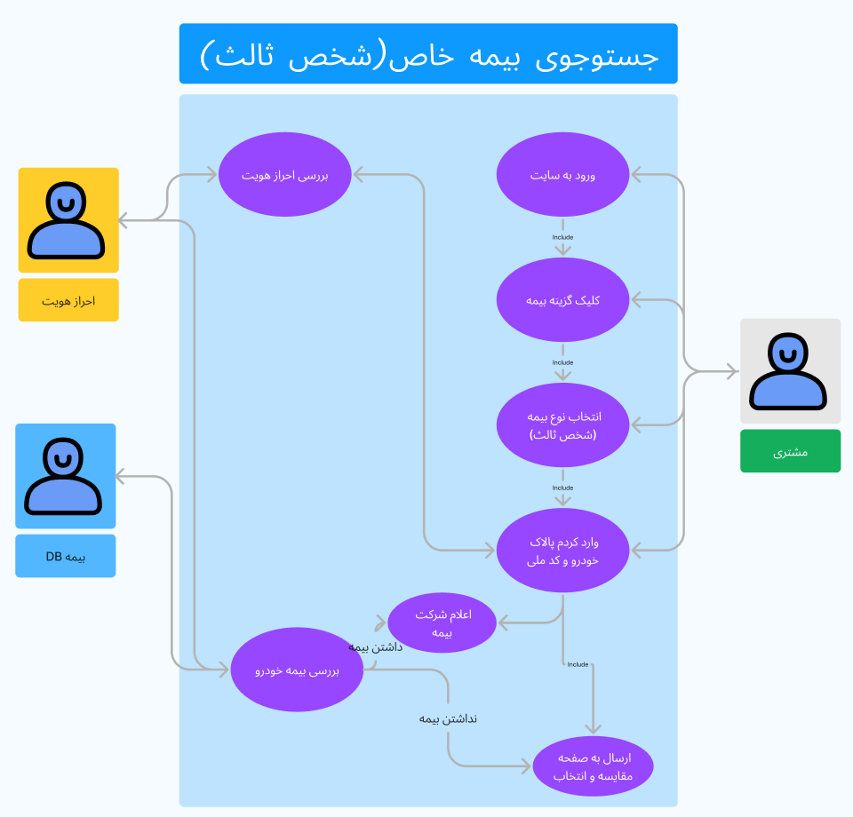

***Sequence diagram***

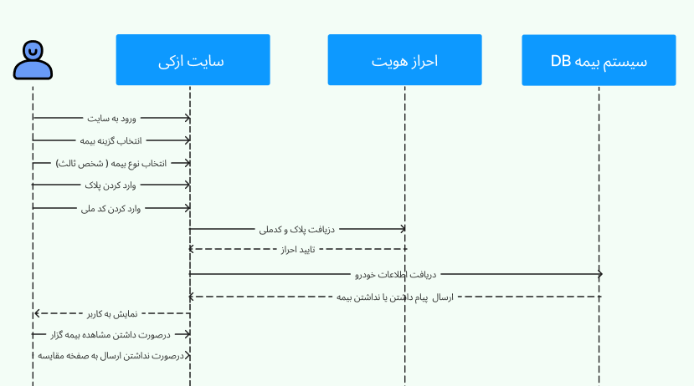

|  |  |  |  |  |  |
| --- | --- | --- | --- | --- | --- |
| **Application Name: Special Insurance Search (Third Party)** | | | | | |
| The purpose of this use case is to select insurance by the user | | | | | **Description** |
| DB authentication and insurance system | | | | | **Factor I see** |
|  | Action Factor | System response | |  | **current Main** |
|  | The user logs in  (2) The user selects the insurance policy  (3) chooses the type of insurance |  | |
|  | (4) Enters license plate and national code | (5) Checks authentication  (6) The information is sent to the DB insurance system | |
|  | 9) If you have insurance, you will see the name of the policy holder  (10) If not, it goes to the insurance comparison page | (7) If the insurance system has the data of the insurer, send it  8) If you do not have insurance, the insurance system will send a data of no insurance | |
|  |  |  | |
|  | Wrong license plate | | -1 |  | **before Condition** |
| Wrong mail code | | -2 |  |
|  | |  |  |
| It should be displayed to the user after confirming the identity of having or not having insurance | | | | | **So Condition** |

**Buying insurance** and **online** payment

***Use case***

1. Becomes a user of the site
2. Selects the desired insurance
3. The system takes the user to the insurance comparison section
4. The user can compare the prices of all insurances and...
5. The user selects the desired insurance
6. The system provides the required insurance information to the user
7. The user can pay his insurance premium in cash and in installments
8. After selecting the system , the user takes you to the information completion section
9. The system displays how to send the insurance (electronic version - printed version)
10. Finally, the user goes to the payment page

**Use case diagram**

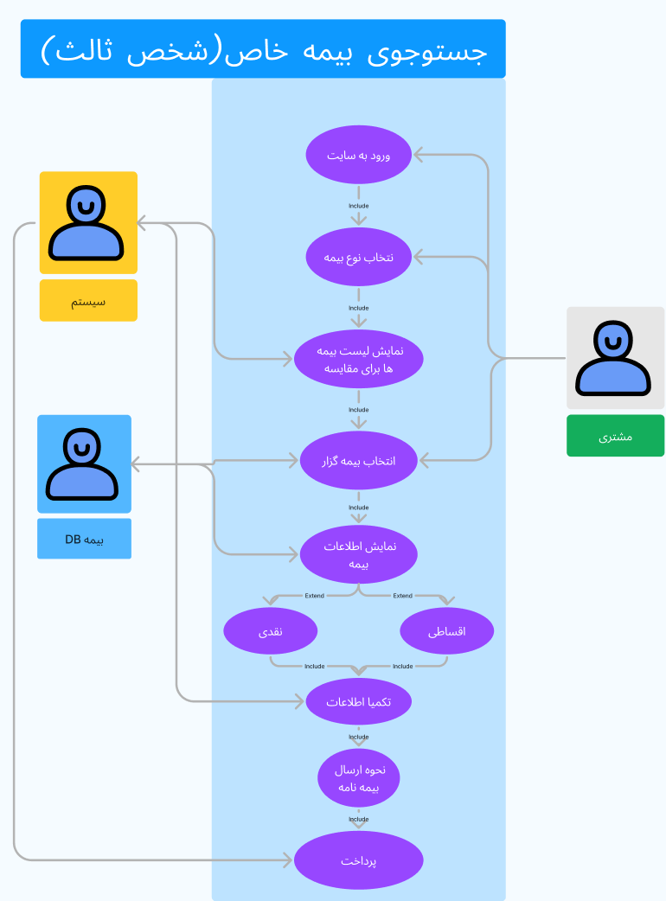

***Sequence diagram***

|  |  |  |  |  |  |
| --- | --- | --- | --- | --- | --- |
| **Application name:** **Buying insurance** and **online** payment | | | | | |
| The purpose of this item is to use it | | | | | **Description** |
| DB insurance system and system | | | | | **Factor I see** |
|  | Action Factor | System response | |  | **current Main** |
|  | The user logs in  (2) The user selects the insurance option  (3) chooses the type of insurance |  | |
|  | (5) The user chooses his own insurer | (4) The insurance system sends the list of desired insurances  (6) The information is sent to the DB insurance system | |
|  | (8) The user chooses between 2 installment options with cash  (10) The user pays the insurance premium | (7) The insurance system sends information about the policy holder  ( | |
|  | (13) The user can receive his insurance policy digitally and physically | (11) The system takes the payment information and transfers it to the insurance system  (12) The insurance system sends the insurance policy | |
|  | Having similar insurance before | | -1 |  | **before Condition** |
| Difficulty paying | | -2 |  |
|  | |  |  |
| If you have insurance, the system will notify you and allow you to change it | | | | | **So Condition** |

Support

***Use case***

1. User after entering the site
2. The site should have blogs related to the type of insurance on the site
3. The site must have an online support section
4. There should be a frequently asked questions section on the site
5. The user should be able to easily solve all the questions before and after the purchase

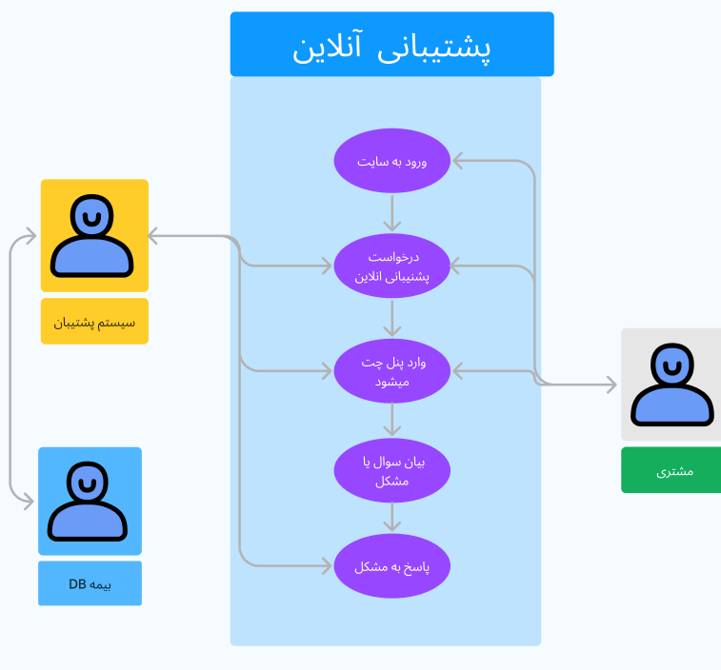

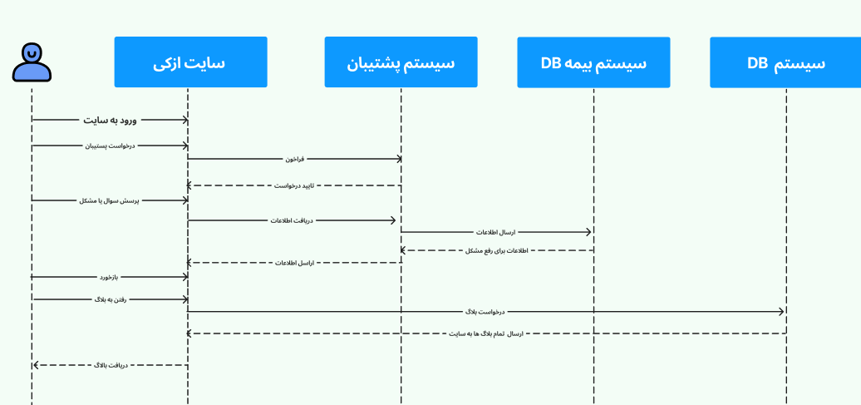 **Sequence diagram**

|  |  |  |  |  |  |
| --- | --- | --- | --- | --- | --- |
| **Application name:** **User support (chat)** | | | | | |
| The purpose of this user support item | | | | | **Description** |
| Support system and DB system and DB insurance system | | | | | **Factor I see** |
|  | Action Factor | System response | |  | **current Main** |
|  | (1) The user logs in  (2) Request for backup | (3) The system calls backup | |
|  | (4) The user asks his problem or question | (5) The postman sends the information to the insurance system  (6) The insurance system sends the solution | |
|  | (7) Submission of feedback by the user |  | |
|  |  |  | |
|  | will be answered by AI | | -1 |  | **before Condition** |
|  | |  |  |
|  | |  |  |
| There is no need for an insurance system if it is a site | | | | | **So Condition** |
| **Application name:** **User support (blog)** | | | | | |
| The purpose of this user support item | | | | | **Description** |
| Support system and DB system | | | | | **Factor I see** |
|  | Action Factor | System response | |  | **current Main** |
|  | (1) The user logs in  (2) Blog request | (3) The system receives the request | |
|  | ( 5 ) The user sees the desired blog | ( 4 ) The system sends blog information | |
|  |  |  | |
|  |  |  | |
|  |  | |  |  | **before Condition** |
|  | |  |  |
|  | |  |  |
|  | | | | | **So Condition** |

***Class Diagram***

